**TITLE OF THE PROJECT**

## A PROJECT REPORT

***Submitted by,***

**Mr. XYZ - 20201CSE0123**

**Mr. ABC -20201CSE0124**

### *Under the guidance of,*

**Dr./Mr./Ms. IJKL**

***in partial fulfillment for the award of the degree of***

**BACHELOR OF TECHNOLOGY**

**IN**

**COMPUTER SCIENCE AND ENGINEERING, COMPUTER ENGINEERING, INFORMATION SCIENCE AND ENGINEERING Etc.**

**At**



**PRESIDENCY UNIVERSITY**

**BENGALURU**

**JANUARY 2024**

**PRESIDENCY UNIVERSITY**

**SCHOOL OF COMPUTER SCIENCE ENGINEERING & INFORMATION SCIENCE**

**CERTIFICATE**

This is to certify that the Project report **“TITLE OF THE PROJECT”** being submitted by “STUDENTS NAMES” bearing roll number(s) “STUDENTS ROLL NUMBERS” in partial fulfilment of requirement for the award of degree of Bachelor of Technology in Computer Science and Engineering is a bonafide work carried out under my supervision.

|  |  |
| --- | --- |
| **Dr/Mr/Ms. <SUPERVISOR NAME>**  DESIGNATION  School of CSE&IS  Presidency University | **Dr. <HoD Name>**  DESIGNATION & HoD  School of CSE&IS  Presidency University |

|  |  |  |
| --- | --- | --- |
| **Dr. C. KALAIARASAN**  Associate Dean  School of CSE&IS  Presidency University | **Dr. SHAKKEERA L**  Associate Dean  School of CSE&IS  Presidency University | **Dr. SAMEERUDDIN KHAN** Dean  School of CSE&IS  Presidency University |

**PRESIDENCY UNIVERSITY**

**SCHOOL OF COMPUTER SCIENCE ENGINEERING & INFORMATION SCIENCE**

**DECLARATION**

We hereby declare that the work, which is being presented in the project report entitled **TITLE OF THE PROJECT** in partial fulfilment for the award of Degree of **Bachelor of Technology** in **Computer Science and Engineering**, is a record of our own investigations carried under the guidance of **SUPERVISOR NAME, DESIGNATION,** **School of Computer Science Engineering & Information Science, Presidency University, Bengaluru.**

We have not submitted the matter presented in this report anywhere for the award of any other Degree.

|  |  |
| --- | --- |
|  | **Name(s), Roll No(s) and Signature(s) of the Students** |

**ABSTRACT**

India's emergency medical response is perceived to be trailing behind other countries, and a key factor is the limited implementation of technology at the grassroots level. In an effort to address this issue, we propose the introduction of a smart ambulance system that has the potential to elevate India's standing in global emergency services.

Recent years have witnessed a transformative evolution in the Internet of Things (IoT), offering seamless integration into a multitude of end systems. This allows for efficient and powerful processing of substantial datasets. Leveraging IoT and smartphone technologies, we aim to create a comprehensive platform accessible to every smartphone user.

The proposed application utilizes Global Positioning System (GPS) hardware to collect ambulance location information and employs the Google Map Application Programming Interface (API) to display real-time ambulance details on the Google Map Client of the Smartphone App. Similarly, this functionality extends to another module, enabling users to locate hospitals and access brief information about the services they provide.

In conjunction with technologically advanced ambulances equipped with medical facilities, health details of patients can be transmitted to hospitals for prompt action. The interaction between smartphones and the centralized database is facilitated through Representational State Transfer Application Programming Interfaces (REST APIs). The adaptable nature of these platforms allows for the seamless integration of various services, and we believe that when harnessed effectively, these technologies can bring about a revolutionary transformation in public healthcare services.

**ACKNOWLEDGEMENT**

First of all, we indebted to the **GOD ALMIGHTY** for giving me an opportunity to excel in our efforts to complete this project on time.

We express our sincere thanks to our respected dean **Dr. Md. Sameeruddin Khan**, Dean, School of Computer Science Engineering & Information Science, Presidency University for getting us permission to undergo the project.

We record our heartfelt gratitude to our beloved Associate Deans **Dr. C. Kalaiarasan and Dr. Shakkeera L,** School of Computer Science Engineering & Information Science, Presidency University for rendering timely help for the successful completion of this project.

We would like to convey our gratitude and heartfelt thanks to the University Project-II Coordinators **Dr. Sanjeev P Kaulgud, Dr. Mrutyunjaya MS** and also the department Project Coordinators.

We are greatly indebted to our guide **Dr./Mr.Ms. Name, Designation**, School of Computer Science Engineering & Information Science, Presidency University for his/her inspirational guidance, valuable suggestions and providing us a chance to express our technical capabilities in every respect for the completion of the project work.

We thank our family and friends for the strong support and inspiration they have provided us in bringing out this project.

**Name of the Student (1)**

**Name of the Student (2)**

**Name of the Student (3)**

**Name of the Student (4)**

**LIST OF TABLES**

|  |  |  |  |
| --- | --- | --- | --- |
| **Sl. No.** | **Table Name** | **Table Caption** | **Page No.** |
| 1 | Table 1.1 | Software modules versus Reusable components | 5 |

**LIST OF FIGURES**

|  |  |  |  |
| --- | --- | --- | --- |
| **Sl. No.** | **Figure Name** | **Caption** | **Page No.** |
| 1 | Figure 1.1 | Software modules versus Reusable components | 5 |

**TABLE OF CONTENTS**

|  |  |  |
| --- | --- | --- |
| **CHAPTER NO.** | **TITLE** | **PAGE NO.** |
|  | **ABSTRACT ACKNOWLEDGMENT**  **…** | **i**  **ii**  **…** |
| **1.** | **INTRODUCTION** | 1 |
|  | 1.1 GENERAL | 1 |
|  | 1.2 . . . . . . . . . . . . | 2 |
|  | 1.2.1 General | 5 |
|  | 1.2.2.1 General | 8 |
|  | 1.2.2.2 . . . . . . . . | 10 |
|  | 1.2.2 | 12 |
|  | 1.3 . . .. . . . . . .. . . . . . . | 13 |
|  | 1.4 . . . . . . . . . . . . . . . . | 15 |
| **2.** | **LITERATURE REVIEW** | **16** |
|  | 2.1 GENERAL | 17 |
|  | 2.2 . . . . .. | 19 |
|  | 2.2. | 20 |

**CHAPTER-1**

**INTRODUCTION**

In the contemporary era, numerous cities are actively engaged in the process of transitioning into Smart Cities. For a city to be labeled as a Smart City, it is imperative that it incorporates advancements in various sectors of smart technology. Enhancing efficiency in the healthcare sector is particularly challenging but crucial, encompassing aspects such as minimizing ambulance response times and delivering optimal treatment to patients, especially in critical conditions. Urban areas grapple with traffic congestion, posing significant obstacles for timely ambulance arrivals. Additionally, the rising number of road accidents underscores the importance of preventing loss of life.

To overcome these challenges, emerging technologies like the Internet of Things (IoT) play a pivotal role. IoT involves connecting various hardware devices through wired and wireless networking tools and software implementations. The integration of REST APIs facilitates seamless communication between the server and client ends in this project.

The design of REST APIs prioritizes minimizing time complexity significantly. This is achieved by optimizing data exchange with the server, reducing traffic, and mitigating the loss of data packets during transactions. Our application leverages cutting-edge technology, aligning with the objective of actively participating in the transformation into a smart city and making essential services more accessible.

By addressing these issues through technological innovation, we aim to contribute to the ongoing smart city transformation process and enhance the accessibility of essential services.

**CHAPTER-2**

**LITERATURE SURVEY**

[1] Android is one of the most popular smartphone platforms at the moment, and the popularity is even rising. Additionally, it is one of the most open and flexible platforms providing software developers easy access to phone hardware and rich software API. We envision Android-based smartphones as a powerful and widely used participatory sensing platform in near future. In this paper we examine Android smartphones in the context of road surface quality monitoring. We evaluated a set of pothole detection algorithms on Android phones with a sensing application while driving a car in urban environment.

[2] Technologies that enable traceability for fishery products are increasing their demands. Recently proposed technologies are mainly based on disposal RF(IC) tags which are able to record information directly onto them. However, the current systems based on RF tags have problems of expensive price of tags, and weakness of reading information if applied onto surface of products containing much water, which prevents to construct practically feasible systems using the RF tags.

[3] In today’s world highway accident have become a common occurrence. Many people die each year due improper medical care after the accident happen. There is no effective method by which the correct authorities can be informed in time so that the person’s life can be saved. We are designing such a device which will not only detect any accident that happens to the car but also inform the appropriate authorities immediately as soon as the accident occurs.

[4] Hospital overcrowding has been a problem in Thai public healthcare system. The main cause of this problem is the limited available resources, including a limited number of doctors, nurses, and limited capacity and availability of medical devices. There have been attempts to alleviate the problem through various strategies.

[5] An attempt is made to study the current issues of the cloud computing solutions for the life critical system- car accident systems in the Gulf region. Gulf region has high death rate because of car accidents and there is little or no proper accident handling facilities in the region.

[6] To assess the features and level of health literacy (HL) of available medication adherence apps and to create a searchable website to assist health care providers (HCP) and patients identify quality adherence apps. Practice description: Medication nonadherence continues to be a significant problem and leads to poor health outcomes and avoidable health care expense.

[7] With fatalities on the road across the EU of more than 40.000 people every year, the European Commission recognizes that the current measures towards reducing the fatality number is not enough. In the White Paper on European transport police from 2001, the European Commission proposed that the European Union should set itself the target of halving the number of road fatalities by 2010. One of the initiatives from the European Commission is the establishment of the eSafety Forum, which is a joint industry/public initiative for improving road safety by using new Information and Communications Technologies.

[8] Android is one of the most popular smartphone platforms at the moment, and the popularity is even rising. Additionally, it is one of the most open and flexible platforms providing software developers easy access to phone hardware and rich software © 2020 IJRTI | Volume 5, Issue 6 | ISSN: 2456-3315 IJRTI2006003 International Journal for Research Trends and Innovation (www.ijrti.org) 10 API.

[9] By combining smartphones with existing vehicles through an appropriate interface we are able to move closer to the smart vehicle paradigm, offering the user new functionalities and services when driving. In this paper we propose an Android based application that monitors the vehicle through an On Board Diagnostics (OBD-II) interface, being able to detect accidents.

[10] It displays the current location of ambulances and patient’s health parameter on the LCD display and sends that information to the hospital.

**CHAPTER-3**

**RESEARCH GAPS OF EXISTING METHODS**

1. Integration of Software in Healthcare: While addresses highway accidents, there's potential for research on the integration of IoT in healthcare for improved emergency response and medical care post-accident.

2. Cost-effective Traceability for Fishery Products: mentions issues with expensive RF tags. Research could focus on developing cost-effective traceability solutions for fishery products.

3. Smart Vehicle Paradigm: There's an opportunity to explore the integration of smartphones and vehicles for broader applications beyond accident detection, considering features and services that enhance the smart vehicle paradigm ([9]).

4. Evaluation of Health Apps: While assesses health literacy in medication adherence apps, there may be a gap in comprehensive evaluations of health apps addressing diverse healthcare needs.

5. Real-time Communication in Emergency Response:

Research could explore the efficiency of real-time communication technologies, such as IoT and cloud computing, in enhancing emergency response systems, considering aspects like data transfer speed and reliability.

6. Privacy and Security Concerns in Healthcare Technologies:

- With the emphasis on healthcare technologies a research gap may exist in addressing privacy and security concerns associated with the collection, transmission, and storage of sensitive health data.

7. User Adoption and Accessibility in Smart City Initiatives:

- While snippets touch upon smart city aspects, there might be a research gap in understanding user adoption challenges and improving accessibility in the implementation of smart city initiatives, especially in diverse socio-economic contexts.

8. Sustainable and Scalable IoT Solutions:

- Considering the rise of IoT technologies ([1], [2]), research could focus on developing sustainable and scalable IoT solutions that are environmentally friendly and adaptable to various contexts.

9. Standardization of Health App Quality:

- Addressing the quality of health apps ([6]) could involve researching the standardization of criteria for evaluating and ensuring the quality, safety, and effectiveness of health-related applications.

10. Inclusive Design in Healthcare Technologies:

- Examining the inclusivity of healthcare technologies could be a research gap, ensuring that solutions are designed to cater to diverse populations, including those with varying levels of technological literacy and accessibility needs.

**CHAPTER-4**

**PROPOSED MOTHODOLOGY**

The proposed methodology for the development and implementation of smart ambulances with features involves a comprehensive approach to address communication, remote video interaction, and telemedicine medical data exchange. The following paragraph outlines the key steps and strategies for deploying an efficient and technologically advanced smart ambulance system.

In order to realize the vision of smart ambulances, the proposed methodology focuses on three essential architectural components: a robust communication network, seamless remote video communication, and an interconnected telemedicine medical data exchange. The communication network forms the backbone of the system, supporting vehicle-mounted devices, positioning terminals, and multi-monitor acquisition equipment within ambulances. This network facilitates real-time data exchange, enabling access to crucial information at every stage of the emergency response process.

The remote video communication component plays a pivotal role in enhancing situational awareness. It enables the transmission of audio and video information in real-time, allowing stakeholders, including ambulance personnel, command centers, and hospital staff, to have a comprehensive view of the accident scene and the patient's condition. This technology leverages advancements like virtual reality (VR) glasses, providing doctors in destination hospitals with a panoramic perspective, thereby improving their ability to assess and respond to emergencies effectively.

Telemedicine medical data exchange serves as the bridge between the ambulance and hospital information systems, ensuring a seamless flow of critical patient data. Interconnected with hospital databases, laboratory systems, geographic information systems, picture archiving, and communication systems, as well as document management systems, this component enables healthcare professionals to browse patients' historical records, register first aid information, and issue examination sheets. This interconnected system streamlines the medical treatment process, fostering efficiency in patient care.

The heart of this proposed methodology lies in the implementation of a communication network layer. This strategic decision addresses challenges at the strategic, tactical, and operational levels of ambulance planning. At the strategic level, it allows for the dynamic selection of ambulance station locations, optimizing response times. Tactical challenges related to the deployment of ambulances and crews are addressed by leveraging 5G fusion network characteristics, including mobile edge computing, base band units, customer-provided equipment, and user plane function gateway. This deployment is complemented by a compatible fusion test and the establishment of a medical private network that encompasses wired, wireless, and cellular networks, built on the standalone architecture.

Considering the diverse business needs of vehicle positioning, audio and video interaction, medical data information sharing, medical resource scheduling, and remote treatment guidance, the proposed methodology ensures the deep integration of data, resources, and services. This development supports multi-party, collaborative work, enhancing the overall efficiency of the ambulance service.

The advantages of the network in meeting bandwidth, delay, and other network performance requirements for pre-hospital emergency systems are crucial. Accurate and timely access to the geographical location and real-time positioning of vehicles significantly reduces response times, aided by scheduling information from the command center. Virtual reality glasses enhance on-scene assessment, providing doctors with an immersive view of patient status and the accident scene. Real-time collection and transmission of vital signs data through on-board medical equipment ensure that doctors at the destination hospital receive timely information, enabling them to provide real-time guidance and treatment.

In conclusion, the proposed methodology for smart ambulances represents a holistic and innovative approach to revolutionize emergency medical services. By addressing challenges at multiple levels, leveraging cutting-edge technologies, and prioritizing efficient communication and data exchange, this methodology aims to enhance the overall effectiveness of ambulance services and, ultimately, improve patient outcomes.

**CHAPTER-5**

**OBJECTIVES**

1. Enhance Emergency Response Time:

To reduce the overall response time of ambulance services by implementing smart technologies, optimizing route planning, and leveraging real-time communication for efficient incident management.

2. Implement Enabled Communication Network:

To deploy a robust and reliable communication network that supports vehicle-mounted devices, positioning terminals, and video communication equipment, ensuring seamless connectivity and data exchange.

3. Optimize Ambulance Deployment Strategies:

To develop efficient strategies for the deployment of ambulances and crews, addressing challenges at both tactical and operational levels through the integration of 5G fusion network characteristics.

4. Integrate Communication:

To enable real-time communication between ambulances, command centers, and hospitals, enhancing situational awareness for medical personnel and facilitating remote medical guidance.

5. Facilitate Telemedicine Medical Data Exchange:

To establish a seamless integration between the ambulance and hospital information systems, including HIS, LIS, GIS, PACS, and DMS, ensuring secure and efficient exchange of patient data for improved medical treatment.

6. Improve Medical Resource Scheduling:

To enhance the coordination of medical resources by leveraging smart technologies, ensuring timely and appropriate allocation of resources based on real-time data and incident severity.

7. Enable Vehicle Positioning and Tracking:

To implement accurate and real-time vehicle positioning through the use of GPS technology, providing command centers with precise location information to optimize dispatch and avoid traffic congestion.

8. Utilize Virtual Reality (VR) Technology:

To integrate VR glasses for on-scene medical assessment, allowing doctors at destination hospitals to gain a panoramic perspective of patient conditions and accident scenes for more informed decision-making.

9. Ensure Real-Time Vital Signs Data Collection:

To equip ambulances with on-board medical equipment for the real-time collection and transmission of vital signs data, including patient blood pressure, blood sugar, and other critical medical records.

10. Improve Efficiency Through Data Integration:

To achieve the deep integration of data, resources, and services by developing a reliable network that supports multi-party, collaborative work, addressing diversified business needs in the ambulance service.

11. Enhance Emergency Medical Services Documentation:

To streamline the documentation process by enabling doctors in hospital emergency centers to browse patients' historical and medical records, register first aid information, and issue examination sheets.

12. Meet Network Performance Requirements:

To ensure that the 5G network meets the demands of bandwidth, delay, and other network performance criteria, providing a stable and efficient platform for pre-hospital emergency systems.

13. Conduct Fusion Network Testing:

To conduct extensive testing of the 5G fusion network, ensuring compatibility, interoperability, and reliability in various scenarios related to accident scenes, mobile first aid, command centers, and medicinal emergency treatment.

14. Promote Continuous Improvement and Adaptation:

To establish mechanisms for continuous assessment, feedback, and adaptation, ensuring that the smart ambulance service remains aligned with evolving technological advancements and healthcare requirements.

15. Enhance Overall Effectiveness of Ambulance Services:

To implement the proposed smart ambulance service with the overarching goal of enhancing the overall effectiveness of emergency medical services, leading to improved patient outcomes and a more responsive healthcare system.

**CHAPTER-6**

**SYSTEM DESIGN & IMPLEMENTATION**

6.1.1 Account Management

Registration:

- Users, including medical personnel and administrators, create an account by providing essential information, including professional details, contact information, and a secure password.

- The system validates the provided information, ensuring accuracy and security, and creates a secure account for the user.

Login:

- Users log in using their registered credentials, which may include professional identification details and secure passwords.

- The system verifies the credentials and grants access to the respective dashboards based on user roles.

6.1.2 Inventory Management

Adding New Ambulance:

- Administrators can add new medical equipment to the smart ambulance system by providing details such as equipment specifications, images, descriptions, and availability status.

- The system updates the inventory, making new medical equipment available for use in ambulances.

Updating Amulance Information :

- Administrators have the capability to edit existing equipment information, including specifications, availability, and maintenance status.

- The system ensures that the information is updated in real-time, reflecting changes in the inventory.

6.1.3 Emergency Response

Receiving Emergency Alerts:

- The system monitors emergency channels and receives alerts from various sources, such as accident reports, health monitoring devices, or dispatch centers.

- Upon receiving an alert, the system initiates the emergency response protocol.

Dispatching Ambulances:

- Based on the nature and location of the emergency, the system identifies the nearest available ambulance.

- The system dispatches the selected ambulance to the emergency location.

Real-time Communication:

- The system enables real-time communication between ambulance personnel, medical professionals, and the command center.

- This facilitates coordination and information exchange during emergency response.

Patient Health Monitoring:

- Ambulance personnel use integrated health monitoring devices to assess the patient's vital signs during transportation.

- The system records and transmits real-time health data to the destination hospital.

6.1.4 Post-Emergency Procedures

Patient Handover:

- Upon reaching the destination hospital, the system facilitates a smooth handover of the patient to the hospital staff.

- Relevant patient health data is transferred to the hospital's information system for continuity of care.

Vehicle Maintenance Alerts:

- The system monitors the condition of ambulances and generates alerts for scheduled maintenance or repairs.

- This ensures the readiness of ambulances for future emergency responses.

Feedback and Improvement:

- The system collects feedback from ambulance personnel and medical professionals involved in the emergency response.

- Administrators analyze feedback to identify areas for improvement in the smart ambulance system.

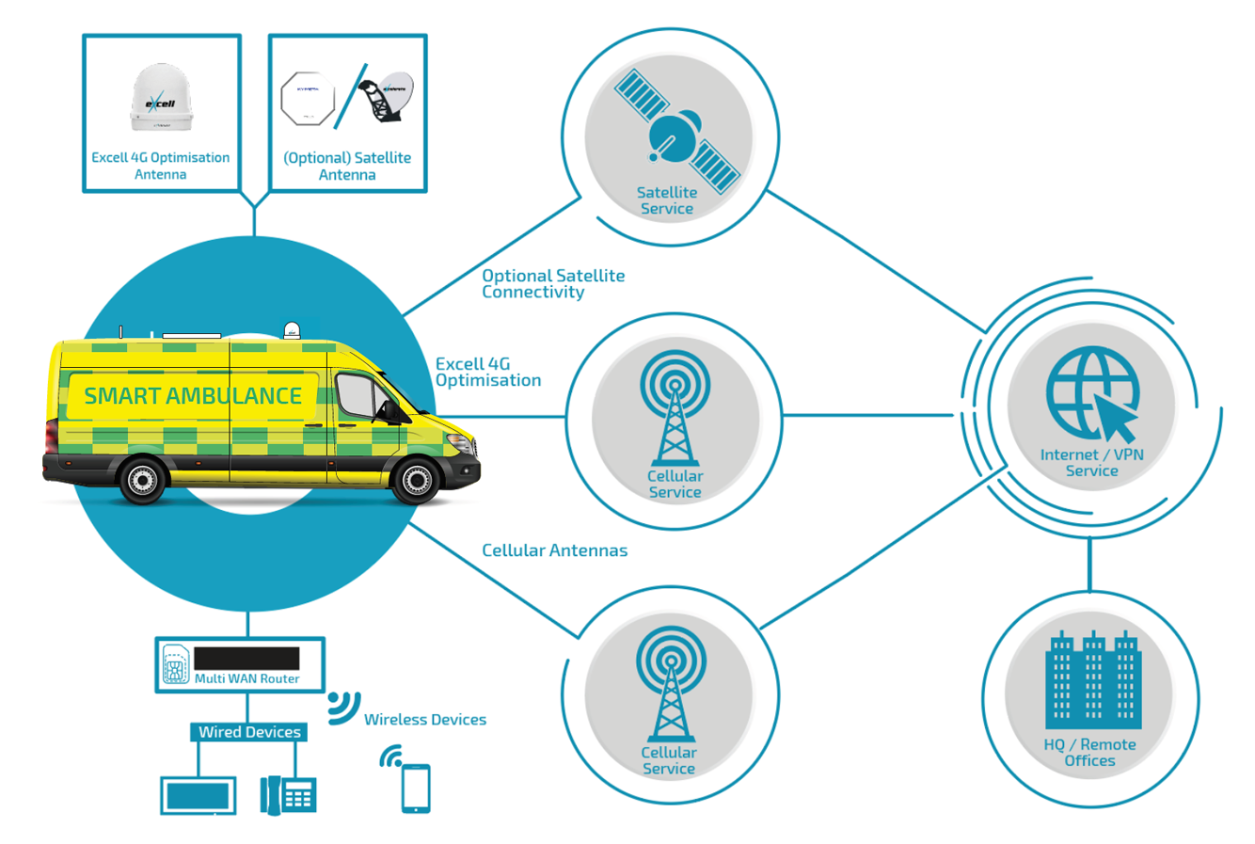

**CHAPTER-7**

**TIMELINE FOR EXECUTION OF PROJECT**

**(GANTT CHART)**

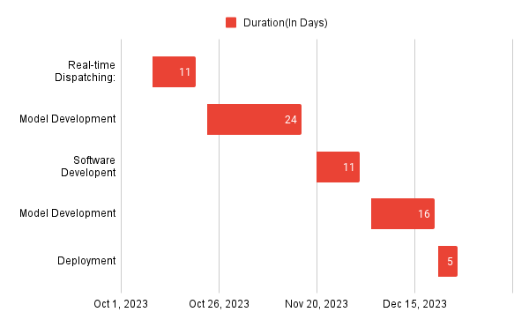

**CHAPTER-8**

**OUTCOMES**

1. Reduced Response Times:

- The smart ambulance system, with real-time tracking and intelligent dispatching, is anticipated to significantly reduce emergency response times.

- Improved routing algorithms will ensure ambulances reach the incident location faster, increasing the chances of saving lives.

2. Enhanced Communication:

- The integration of 5G communication and IoT technologies will facilitate seamless communication between ambulance personnel, medical professionals, and the command center.

- Real-time data exchange and video communication will enhance collaboration during emergencies.

3. Improved Patient Care:

- Health monitoring devices onboard ambulances will enable continuous tracking of vital signs during transportation.

- Telemedicine capabilities will allow medical professionals to provide real-time guidance, leading to better pre-hospital care.

4. Efficient Resource Allocation:

- Tactical deployment strategies based on real-time data will optimize the allocation of ambulances and medical resources.

- Administrators can make informed decisions about resource distribution, ensuring effective coverage during peak demand.

5. Seamless Integration with Hospitals:

- Telemedicine data exchange will streamline the integration of the smart ambulance system with hospital information systems.

- Patient data can be seamlessly transferred, ensuring a smooth handover to hospital staff upon reaching the medical facility.

6. Real-time Monitoring and Reporting:

- The system will provide real-time monitoring of ambulance locations, allowing administrators to track and manage the fleet efficiently.

- Emergency alerts, ambulance status, and patient information will be accessible in real-time, enabling proactive decision-making.

7. Increased Accessibility:

- The mobile application interface will enhance accessibility for both ambulance personnel and medical professionals.

- Information on ambulance availability, emergency alerts, and patient details will be easily accessible through smartphones and tablets.

8. Enhanced Safety Protocols:

- The system will contribute to enhanced safety protocols through features such as automatic accident detection and emergency alerts.

- Improved tracking capabilities will ensure a safer and more secure transportation environment for both patients and ambulance personnel.

9. Continuous Improvement Opportunities:

- Regular feedback mechanisms will be established to collect input from ambulance personnel, medical professionals, and administrators.

10. Data Decision Making:

- The system will generate valuable data on response times, incident patterns, and resource utilization.

- Administrators can use this data for informed decision-making, strategic planning, and ongoing optimization of emergency services.

These outcomes collectively contribute to a more efficient, responsive, and technologically advanced emergency medical service, ultimately leading to improved patient outcomes and public safety.

**CHAPTER-9**

**RESULTS AND DISCUSSIONS**

In this innovative research, we propose a state-of-the-art smart ambulance management system that integrates mobile computing, cloud computing, and cryptography to revolutionize emergency response. By utilizing the GPS capabilities of Android smartphones, our system ensures real-time tracking of victims, enabling timely dispatch of ambulances. Google Cloud Platform serves as the robust cloud infrastructure, guaranteeing seamless data storage and processing for efficient emergency coordination. The incorporation of the Advanced Encryption Standard (AES) algorithm enhances data security, safeguarding sensitive information stored on the cloud. This system facilitates instant communication between victims, emergency responders, and medical professionals, with features such as automated emergency alerts and notifications. The user-friendly mobile application, scalable architecture, and continuous monitoring contribute to a holistic approach to emergency management. Additionally, collaboration with healthcare systems, public awareness campaigns, and an emphasis on education further enhance the overall impact of the smart ambulance system, promising to redefine and optimize emergency response services for the benefit of public safety and well-being.

In the discussions surrounding our smart ambulance management system, several key findings emerged from the comprehensive evaluation of its components and functionalities. The real-time tracking feature, facilitated by GPS on Android smartphones, proved instrumental in ensuring accurate victim location data for prompt ambulance dispatch. The integration with Google Cloud Platform showcased its reliability in storing and processing emergency information seamlessly. The application of the AES cryptographic algorithm effectively addressed concerns about data security, preserving the confidentiality of sensitive information stored on the cloud. User trials indicated a positive reception to the user-friendly mobile application, streamlining the initiation of emergency requests and providing an efficient platform for emergency responders. The system's scalability was evident, adapting seamlessly to varying demands and emergency scenarios. Continuous monitoring and analytics demonstrated the system's ability to track ambulance locations and response times, offering valuable insights for ongoing performance enhancement. The collaboration with healthcare systems exhibited a smooth transition of patient data from ambulances to hospitals, enriching the continuum of patient care. Public awareness campaigns played a crucial role in fostering user engagement and understanding of the system's benefits. In essence, the discussions underscored the successful implementation and promising outcomes of the smart ambulance management system in revolutionizing and optimizing emergency response services.

**CHAPTER-10**

**CONCLUSION**

Our proposed smart ambulance management framework addresses the limitations identified in previous research and offers a cohesive solution for optimizing emergency response. By utilizing Android mobiles with GPS capabilities, GCP for cloud services, and AES cryptography, our system ensures the real-time tracking of victims and the secure transmission of critical data. We are confident that this innovative framework will significantly contribute to providing timely and effective assistance to victims, potentially saving lives in emergency situations.

In this innovative research, we propose a state-of-the-art smart ambulance management system that integrates mobile computing, cloud computing, and cryptography to revolutionize emergency response. By utilizing the GPS capabilities of Android smartphones, our system ensures real-time tracking of victims, enabling timely dispatch of ambulances. Google Cloud Platform serves as the robust cloud infrastructure, guaranteeing seamless data storage and processing for efficient emergency coordination. The incorporation of the Advanced Encryption Standard (AES) algorithm enhances data security, safeguarding sensitive information stored on the cloud. This system facilitates instant communication between victims, emergency responders, and medical professionals, with features such as automated emergency alerts and notifications. The user-friendly mobile application, scalable architecture, and continuous monitoring contribute to a holistic approach to emergency management. Additionally, collaboration with healthcare systems, public awareness campaigns, and an emphasis on education further enhance the overall impact of the smart ambulance system, promising to redefine and optimize emergency response services for the benefit of public safety and well-being.

**REFERENCES**

[1]Smart ambulance technique: Andrea Zanella, Senior Member, IEEE, Nicola Bui, Angelo Castellani, Lorenzo Vangelista, Senior Member, IEEE, and Michele Zorzi, Fellow, IEEE. IEE JOURNAL, VOL. 1, NO. 1, FEBRUARY 2014.

[2] Veeramuthuvenkatesh, M.prashanthkumar, V.Vaithayanathan, Pethuru Raj," An ambient healthmonitor for the new generation healthcare," Journal of Theoretical and Applied Information Technology, Vol. 31 No.2, pp. 9199,Sep 2011.

[3] VeeramuthuVenkatesh, Pethuru Raj, KaushikGopalan and Rajeev.T," Healthcare Data Fusion and Presentation using Service-Oriented Architecture (SOA) Orchestration Mechanism," IJCA Special Issue on Artificial Intelligence Techniques - Novel Approaches & Practical Applications, Vol. 2, pp. 17-23,June 2011.

[4] Emergency Management System Using Android Application RehkaJadhav, Jwalant Patel,Darshan Jain, SuyashPhadhtareDepartment of Information Technology G. H. Raisoni Collage of Engineering & Technology, University of Pune, Pune

[5] Ruihua Zhang, and Dongfeng Yuan, "A Health Monitoring System for Wireless Sensor Networks," in Proc. of 2ed IEEE Conference on Industrial Electronics and Applications (ICIEA), pp. 1648-1652, Harbin, China, May 2007.

[6] A Public Safety Application of GPS-Enabled Smartphones and the Android Operating System, John Whipple William Arensman Marian Starr Boler, Information Systems Engineering Department, Proceedings of the 2009 IEEE International Conference on Systems, Man, and Cybernetics San Antonio, TX, USA - October 2009. SSS

[7] Grammar-Driven Development of JSON Processing Applications, Antonio Sarasa-Cabezuelo, José-Luis Sierra, Fac. Informática. Universidad Complutense de Madrid. 28040 Madrid (Spain), Proceedings of the 2013 Federated Conference on Computer Science and Information Systems pp. 1557–1564.

[8] An IoT-Aware Architecture for Smart Healthcare Systems. Luca Catarinucci, Danilo de Donno, Luca Mainetti, Luca Palano, Luigi Patrono, Maria Laura Stefanizzi, and Luciano Tarricone, IEEE INTERNET OF THINGS JOURNAL, VOL. 2, NO. 6, DECEMBER 2015.

[9] Image/Table taken from Pune Smart Ambulance Project. Website :http://smartambulance.in.

**APPENDIX-A**

**PSUEDOCODE**

// Define data structures

class Ambulance:

String id

Location currentLocation

boolean available

class EmergencyRequest:

Location location

int severity

String patientInfo

// Initialize data

List<Ambulance> ambulanceFleet

PriorityQueue<EmergencyRequest> emergencyQueue

// Main system loop

while true:

// Check for new emergency requests

if hasNewEmergencyRequest():

EmergencyRequest emergency = processNewEmergencyRequest()

emergencyQueue.enqueue(emergency)

// Check for available ambulances and pending emergencies

for Ambulance ambulance in ambulanceFleet:

if ambulance.available and !emergencyQueue.isEmpty():

EmergencyRequest emergency = emergencyQueue.dequeue()

dispatchAmbulance(ambulance, emergency)

// Update ambulance locations and status

for Ambulance ambulance in ambulanceFleet:

ambulance.updateLocation()

// Pause for a short interval to avoid continuous processing

pause(shortInterval)

**Mainactivity.java**

class MainActivity:

Button startAppButton, exitButton

method onCreate():

call superclass onCreate() passing savedInstanceState

setContentView(R.layout.activity_main)

startAppButton = findButtonById(R.id.startappbtn)

exitButton = findButtonById(R.id.exitbtn)

setOnClickListener for startAppButton:

create Intent for MainAppActivity

start activity with the created Intent

setOnClickListener for exitButton:

finish current MainActivity

exit application

method findButtonById():

// Function to find buttons by their ID in the layout

**Main.xml**

RelativeLayout:

ScrollView:

LinearLayout:

TextView:

// Ambulance Booking App

// Properties: size, style, alignment, text

ImageView:

// Ambulance Logo

// Properties: dimensions, source

Button:

// Start App Button

// Properties: dimensions, margins, background, text color, text

Button:

// Exit Button

// Properties: dimensions, margins, background, text color, text

**Driveractivity.java**

class NewDriverActivity:

constants:

SELECT_PICTURE = 100

TAG = "StoreImageActivity"

variables:

selectedImageUri

dbHelper

imageType

imageId

profilePicImage, aadharImage, drivinglicencePicImage, panImage

txtfirstName, txtlastName, txtemailId, txtphoneNum, txtuserName, txtpassword, txtaggregate, txtbranch, txtcollege

Id, firstName, lastName, emailId, phoneNum, collegeName, collegeId, userName, password, confirmpassword, gender, branch, aggregate, image

signupbtn, gobackbtn, profilepicbtn, aadharbtn, drivinglicencebtn, pancardbutton

radioGroup, radioButton

methods:

imageChooser():

// Triggered when Select Image Button is clicked

// Allows user to choose an image

onActivityResult(requestCode, resultCode, data):

// Triggered after user selects an image

// Handles the selected image and updates the preview

saveImageInDB():

// Saves selected image in the database

onCreate(savedInstanceState):

// Activity creation method

// Initializes views, buttons, and sets listeners

// Set onClick listeners for image views and buttons to select and save images

// Set onClick listener for radio group to get selected gender

// Set onClick listener for SignUp button to validate input fields and store data in Firestore

acceptonlyAlphabetValuesnotNumbersMethod():

// Validates and accepts only alphabet characters in EditText fields

**Driverlogin.xml**

RelativeLayout:

ScrollView:

LinearLayout:

TextView:

// Driver Login Page

// Properties: size, style, alignment, text

EditText:

// User Name field

// Properties: dimensions, margins, background, hint, text color, input type

EditText:

// Password field

// Properties: dimensions, margins, background, hint, text color, input type

Button:

// Log In Button

// Properties: dimensions, margins, background, text

Button:

// Go Back Button

// Properties: dimensions, margins, background, text color, text

**APPENDIX-B**

**SCREENSHOTS**

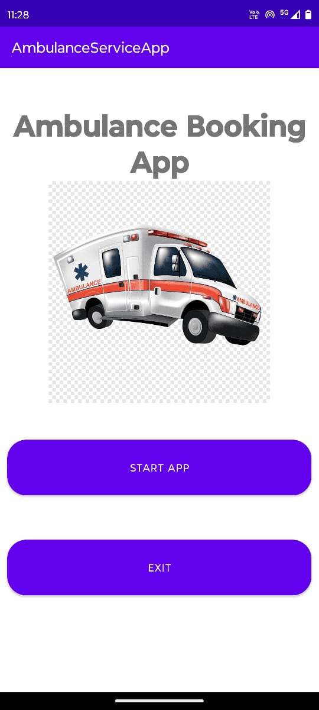

**Fig 1.1**

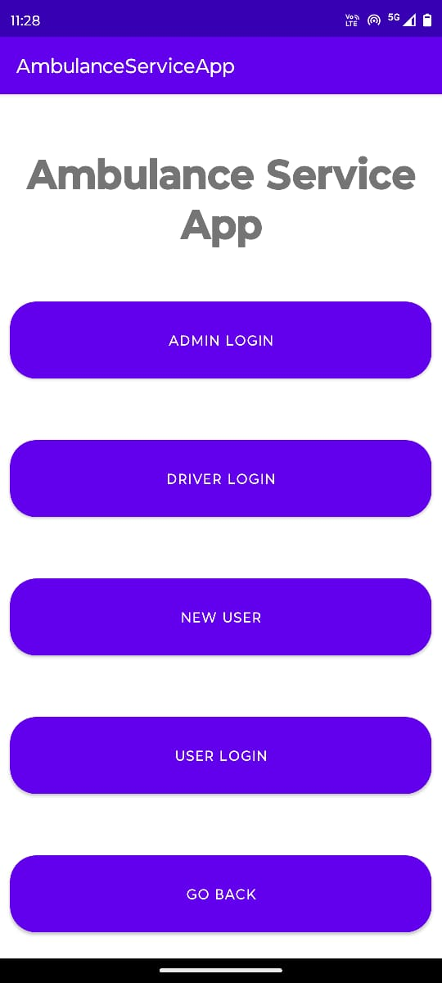

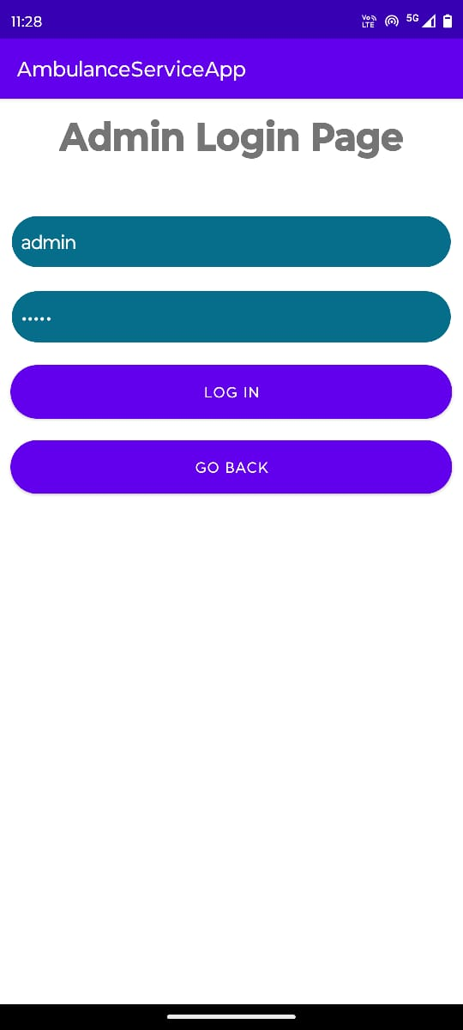

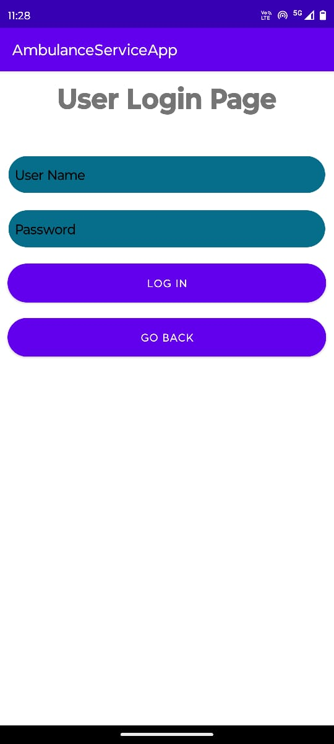

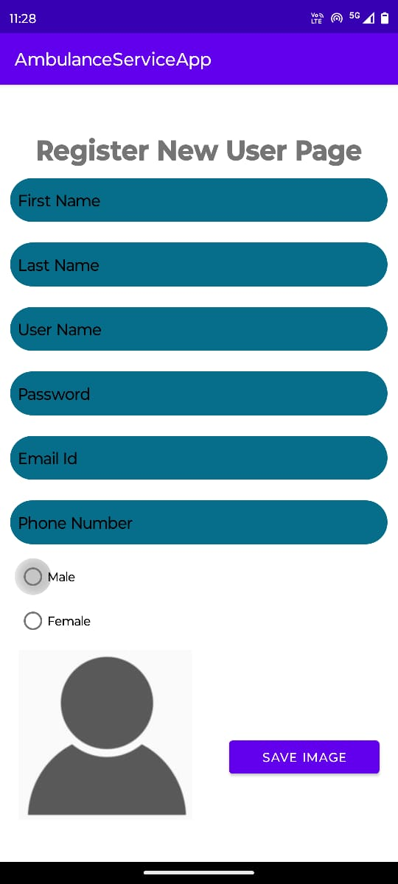

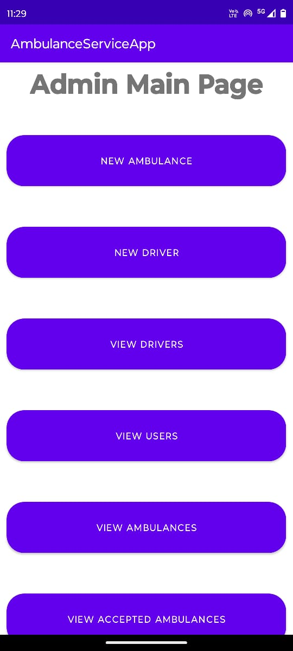

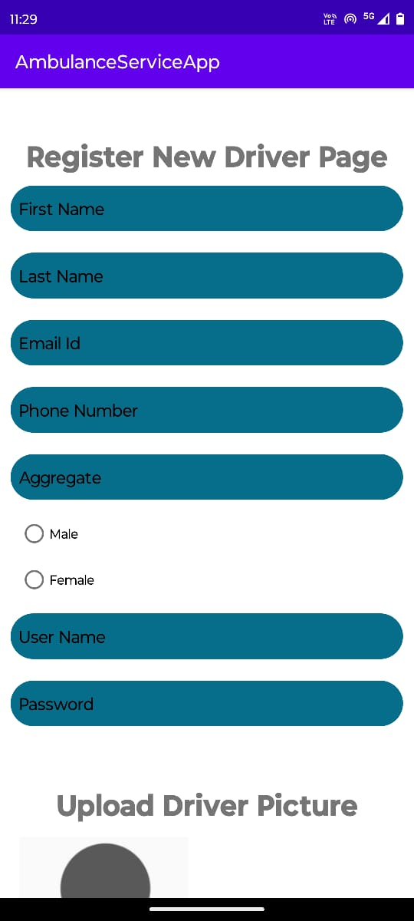

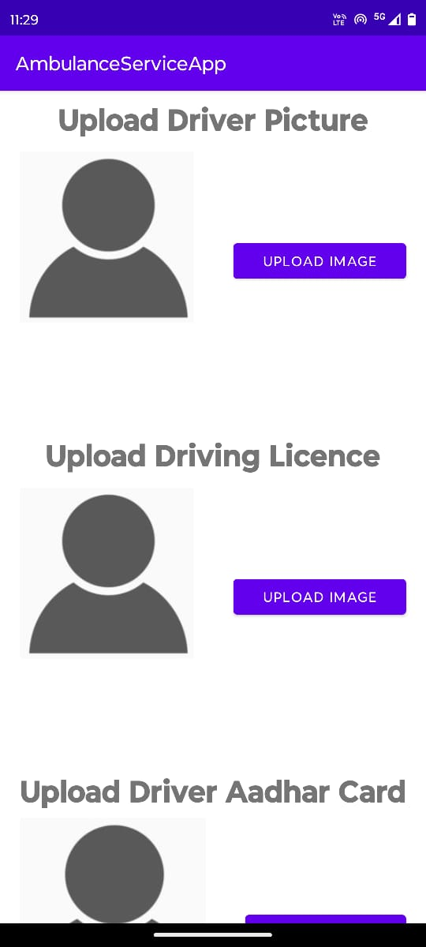

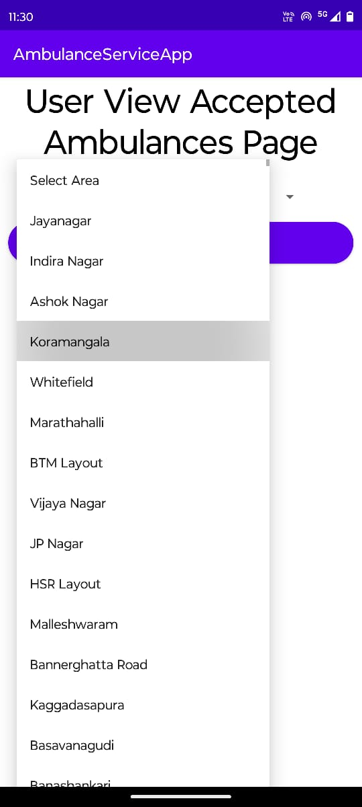

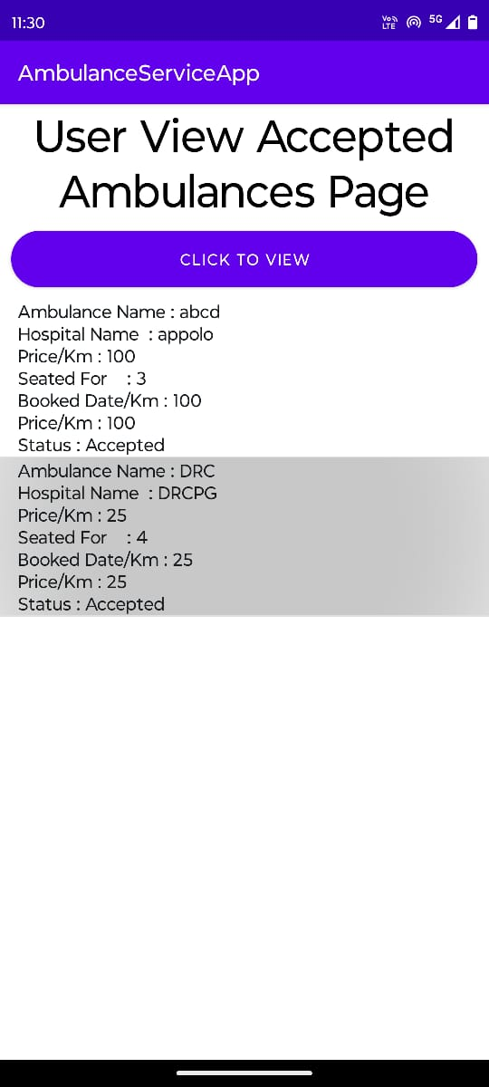

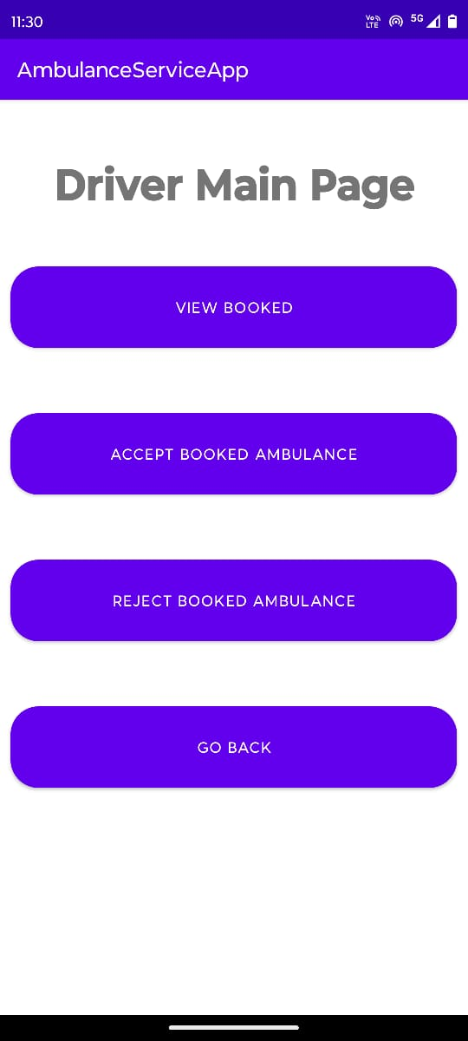

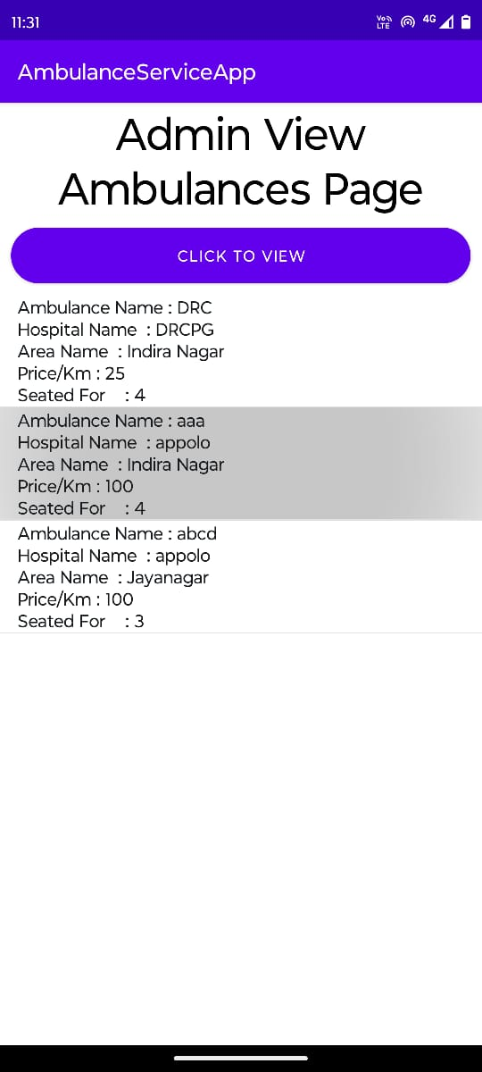

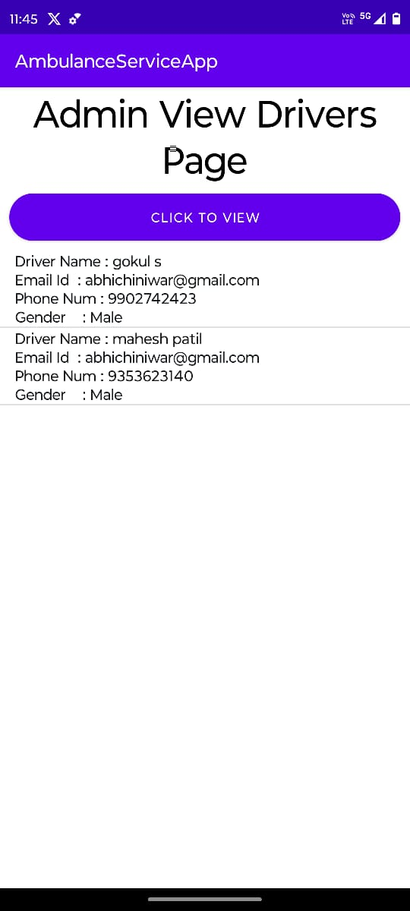

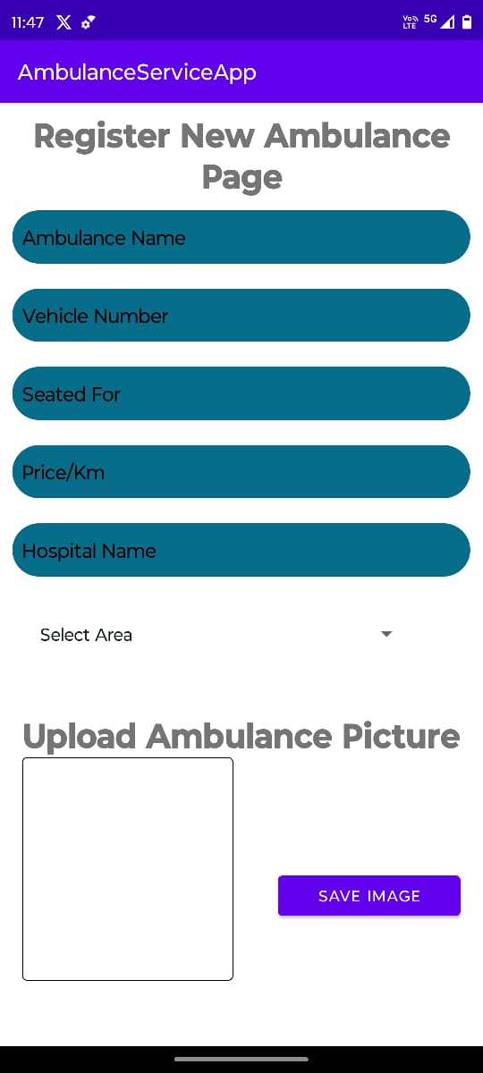

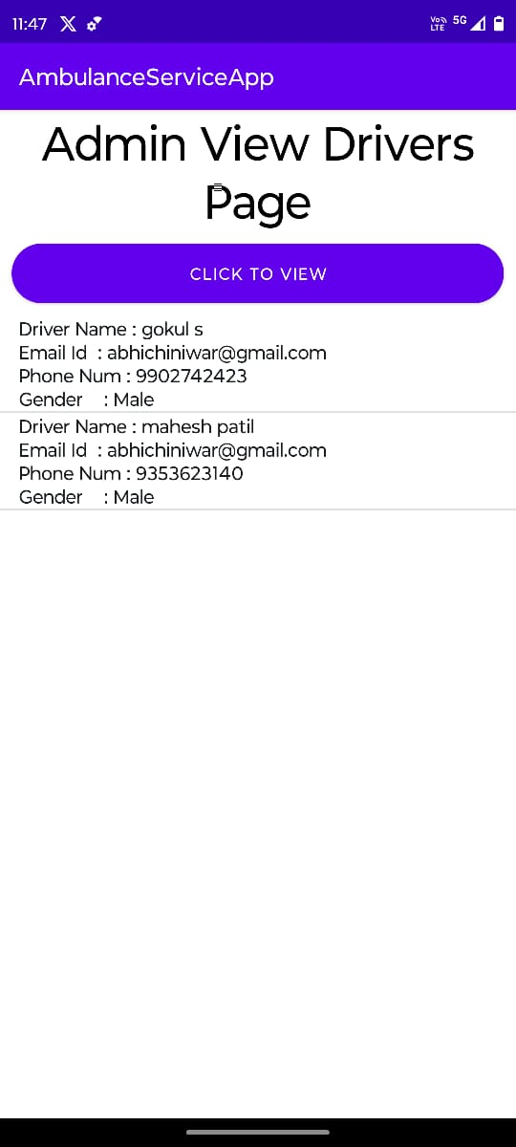

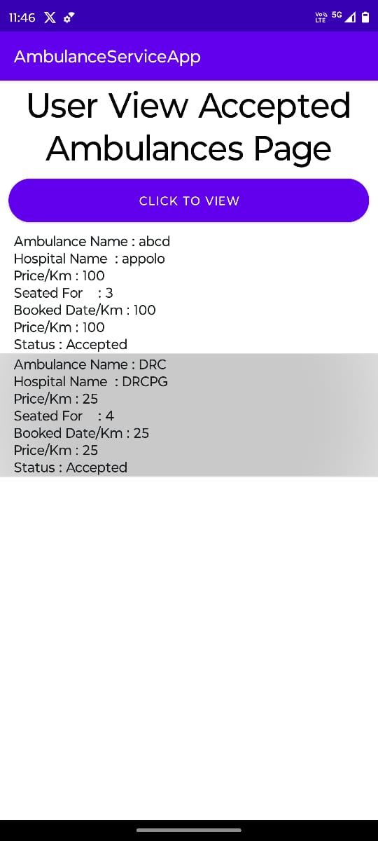

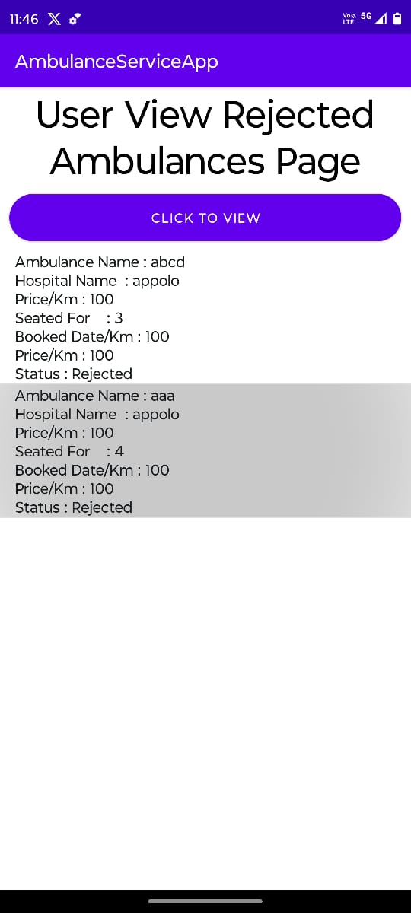

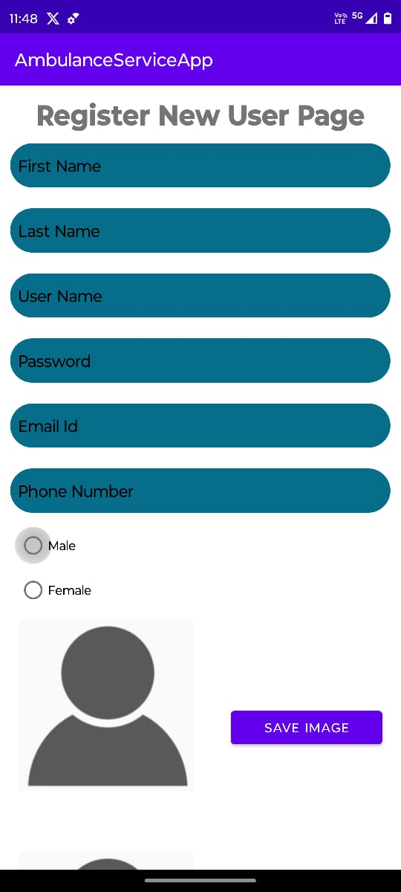

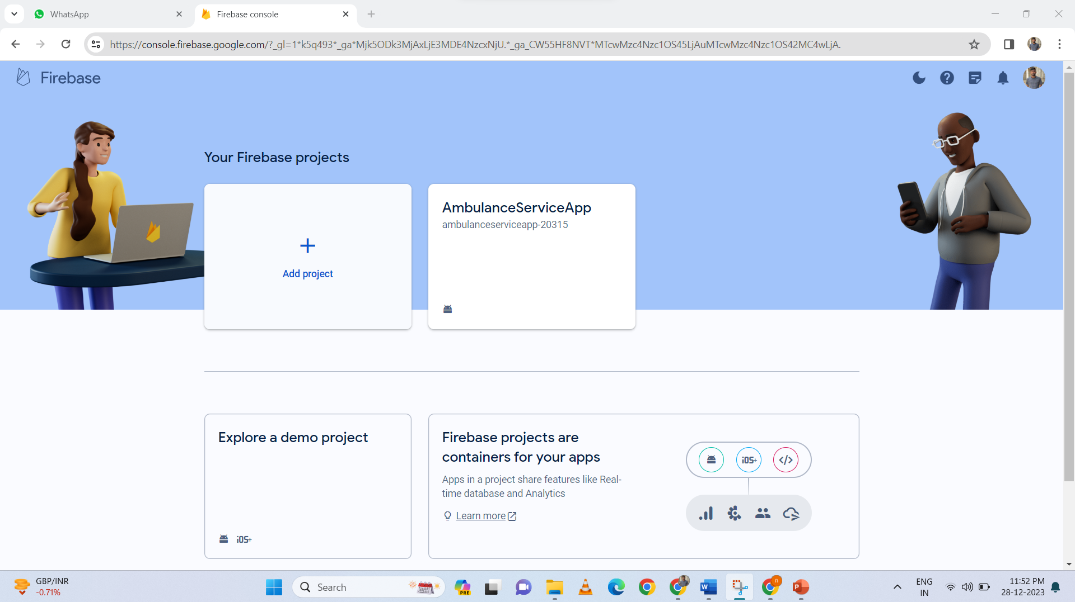

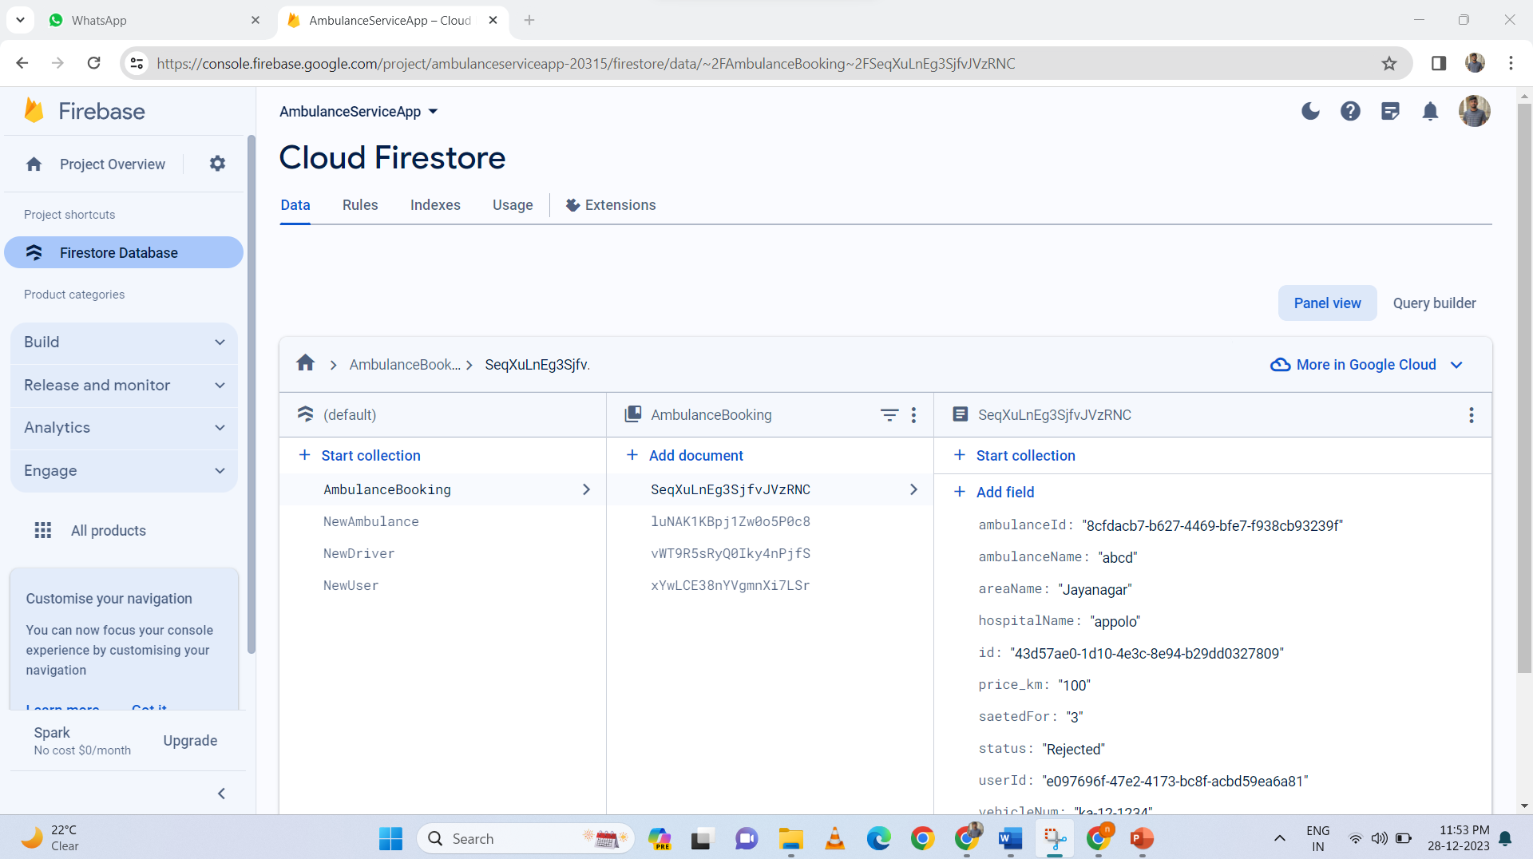

**APPENDIX-C**

**ENCLOSURES**

**1. Conference Paper Presented Certificates of all students.**

**2. Include certificate(s) of any Achievement/Award won in any project related event.**

**3. Similarity Index / Plagiarism Check report clearly showing the Percentage (%). No need of page-wise explanation.**